Required resources:
- Source : ADLS Gen2
- Destination : Databricks Unity Catalog Delta Tables
- Transformations : azure data bricks- Pyspark
- app registration
- key vaults

Architecture diagram:
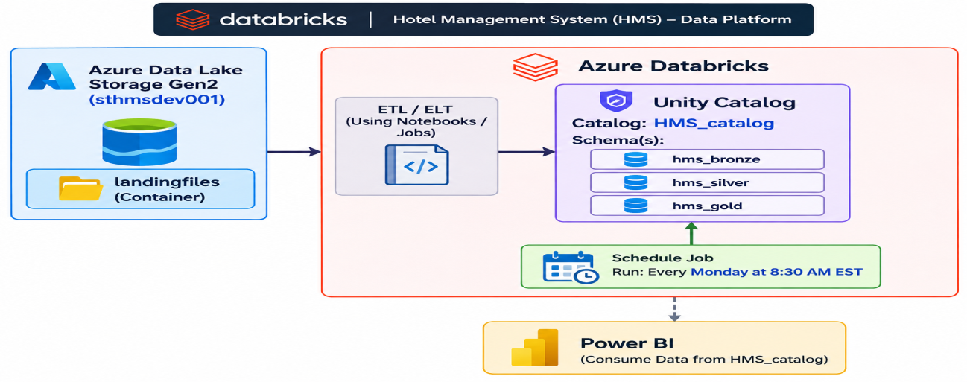

Phase 1: Azure Infrastructure Setup

Step 1.1: Create Resource Group
GUI Steps:
- Go to Azure Portal
- Click "Create a resource" → Search "Resource group"
- Fill in:
  - Subscription: Our subscription detail
  - Resource group name: rg-hms-dev-centralus
  - Region: Central India
- Click "Review + create" → "Create"

Step 1.2: Create Storage Account (ADLS Gen2)
- Click "Create a resource" → Search "Storage account"
- Fill in:
  - Subscription: Our subscription detail
  - Resource group: rg-hms-dev-centralus
  - Storage account name: sthmsdev001
  - Region: Central India
  - Performance: Standard
  - Redundancy: Locally-redundant storage (LRS)
- Click "Advanced" tab:
  - Enable hierarchical namespace: Checked ✓
- Click "Review + create" → "Create"

Step 1.3: Create Containers
GUI Steps:
- Go to your storage account →Data Storage - > "Containers" (left menu)
- Click "+ Container" for each:
  - Name: landingfiles → Public access level: Private → Create

Step 1.3: Create Containers
GUI Steps:
- Go to your storage account →Data Storage - > "Containers" (left menu)
- Click "+ Container" for each:
  - Name: bronze → Public access level: Private → Create

Uploading data into container
- Go to storage account bankingstorageprojecto1
- Click "Containers" → Click "landingfiles"
- Click "Upload" → "Browse for files"
- Select all 1 CSV files:
  - bookings.csv
  - hotles.csv
  - rooms.csv
  - reviews.csv
  - payments.csv
  - guests.csv
- Click "Upload"

Step 1.4: Create Databricks Workspace
GUI Steps:
- Click "Create a resource" → Search "Azure Databricks"
- Fill in:
  - Workspace name: dbw-hms-dev-centralus
  - Resource group: rg-hms-dev-centralus
  - Location: Central India
  - Pricing Tier: Premium (required for Unity Catalog)
- Click "Review + create" → "Create"

Step 1.5: Create apps Registration
GUI Steps:
- Click "Create a resource" → Search " apps Registration”
- Fill in.
- New Registration: app-hms-dev-adls-access
- New Secrets – app_hms_client_secret
We will get below information
- Client – Id and Tenant ID will get from Overview
- Client-Secrets will get value when we are creating New Secrets

- Go to Storage Account and click IAM
- Click RBAC
- Select BLOB Storage Data Contributor
- Select member as app-hms-dev-adls-access registration and Assign access.

Step 1.6: Create Key Vault
GUI Steps:
- Click "Create a resource" → Search " Key Vault”
- Fill in.

- Resource group: rg-hms-dev-centralus
- Key vault name: kv-hms-dev-centralus-001
- Location : Central India
- Pricing Tier : standard
In Access configuration tab we need to select Azure Role Based Access control
- Click "Review + create" → "Create"

- Grant access Key vault administrator for creating secrets in key vault.

- Go to IAM click <add> Role assignment
- Search key vault administrator and select
- Click member and select portal id

- Grant access Key vault secret user

- Go to IAM click <add> Role assignment
- Search key vault secret user and select
- Click member and select AzureDatabricks

- we created two secrets below

- Client ID : app_hms_client_id
- Client Secrets : app_hms_client_secret

Step 1.6: Create Scope
GUI Steps:
- Click below address on browser search bar.
https://adb-7405618662963717.17.azuredatabricks.net/?o=7405618662963717#secrets/createScope
- Fill in.
Scope Name : app_hms_scope
DNS Name : key vault id from key vault properties
Resource id : Resource id from key vault properties

Display Scope –
dbutils.secrets.listScopes()
Display all Secrets for particular Scope.
dbutils.secrets.list(scope='app_hms_scope')

Step 1.7
Notebook1 – pulling data from landingfiles and load into delta Lake table in bronze layer

from pyspark.sql.functions import *
from pyspark.sql import *
from pyspark.sql.types import *

dbutils.widgets.text("Storage_name", "sthmsdev001")
dbutils.widgets.text("container_name", "landingfiles")
Storage_name = dbutils.widgets.get("Storage_name")
container_name = dbutils.widgets.get("container_name")

spark.conf.set(
f"fs.azure.account.auth.type.{Storage_name}.dfs.core.windows.net",
"OAuth"
)

spark.conf.set(
f"fs.azure.account.oauth.provider.type.{Storage_name}.dfs.core.windows.net",
"org.apache.hadoop.fs.azurebfs.oauth2.ClientCredsTokenProvider"
)

spark.conf.set(
f"fs.azure.account.oauth2.client.id.{Storage_name}.dfs.core.windows.net",dbutils.secrets.get(scope="app_hms_scope", key="app-hms-clinet-id"))

spark.conf.set(
f"fs.azure.account.oauth2.client.secret.{Storage_name}.dfs.core.windows.net",dbutils.secrets.get(scope="app_hms_scope", key="app-hms-client-secret"))

spark.conf.set(
f"fs.azure.account.oauth2.client.endpoint.{Storage_name}.dfs.core.windows.net",
"https://login.microsoftonline.com/65583477-d432-469c-b4af-ab046853916f/oauth2/v2.0/token",
)

source_path = f"abfss://{container_name}@{Storage_name}.dfs.core.windows.net/"
tables = ["bookings", "guests","hotels","payments","reviews","rooms"]

for table_name in tables:
full_source_path = source_path + table_name + ".csv"

#Read Data from landing files
df = (spark.read.format("csv")\
.option("header", "true")\
.option("inferSchema", "true")\
.load(full_source_path)\
.withColumn("Action_TimeStamp",current_timestamp())\
.withColumn("Created_by",lit("Ank1221"))\
.withColumn("Batch_id",date_format(current_timestamp(),"yyyyMMddHHmmss"))\
.withColumn("Source_file_name",input_file_name()))

#Write data into Bronze layer
df.write.format("delta").mode("overwrite").saveAsTable(f"hms_catalog.hms_Bronze.{table_name}")

Step 1.8

Notebook2 – pulling data from bronze layer and load into delta Lake table in silver layer

dbutils.widgets.text("Catalog_name", "hms_catalog")
dbutils.widgets.text("Schema_name", "hms_bronze")

Catalog_name = dbutils.widgets.get("Catalog_name")
Schema_name = dbutils.widgets.get("Schema_name")

check_catalog_availbility ={ rows[0] for rows in spark.sql(f"SHOW CATALOGS LIKE '{Catalog_name}'").collect()
}

if Catalog_name not in check_catalog_availbility:
print(f"Catalog is not verified. Please create the catalog {Catalog_name}")
else:
print(f"Catalog is verified. {Catalog_name}")

check_schema_availbility ={ rows[0] for rows in spark.sql(f"SHOW Schemas IN {Catalog_name}.{Schema_name}").collect()
}

if Catalog_name not in check_catalog_availbility:
print(f"Schema is not verified. Please create the catalog {Schema_name}")
else:
print(f"Schema is verified. {Schema_name}")

Catalog is verified. hms_catalog
Catalog is verified. hms_bronze

#read data bronze layer
bookings = spark.table("hms_catalog.hms_bronze.bookings")

#Count row in bronze layer
bookings_count = bookings.count()

#drop Duplicate rows
bookings = bookings.dropDuplicates(['booking_id'])

#count distinct row
bookings_count2 = bookings.count()

print("total count before dropping duplicates: ", bookings_count)
print("total count after dropping duplicates: ", bookings_count2)

total count before dropping duplicates: 5010
total count after dropping duplicates: 5000

#read data bronze layer
guests = spark.table("hms_catalog.hms_bronze.guests")

#Count row in bronze layer
guests_count = guests.count()

#drop Duplicate rows
guests = guests.dropDuplicates(['guest_id'])

#count distinct row
guests_count2 = bookings.count()

print("total count before dropping duplicates: ", guests_count)
print("total count after dropping duplicates: ", guests_count2)

total count before dropping duplicates: 1011
total count after dropping duplicates: 5000

#read data bronze layer
rooms = spark.table("hms_catalog.hms_bronze.rooms")

#Count row in bronze layer
rooms_count = rooms.count()

#drop Duplicate rows
rooms = rooms.dropDuplicates(['room_id'])

#count distinct row
roomss_count2 = rooms.count()

print("total count before dropping duplicates: ", rooms_count)
print("total count after dropping duplicates: ", roomss_count2)

total count before dropping duplicates: 495
total count after dropping duplicates: 486

hotels = spark.table("hms_catalog.hms_bronze.hotels")

#Count row in bronze layer
hotels_count = hotels.count()

#drop Duplicate rows
hotels = hotels.dropDuplicates(['hotel_id'])

#count distinct row
hotels_count2 = hotels.count()

print("total count before dropping duplicates: ", hotels_count)
print("total count after dropping duplicates: ", hotels_count2)

total count before dropping duplicates: 25
total count after dropping duplicates: 20

payments= spark.table("hms_catalog.hms_bronze.payments")

#Count row in bronze layer
payments_count = payments.count()

#drop Duplicate rows
payments = payments.dropDuplicates(['payment_id'])

#count distinct row
payments_count2 = payments.count()

print("total count before dropping duplicates: ", payments_count)
print("total count after dropping duplicates: ", payments_count2)

total count before dropping duplicates: 5009
total count after dropping duplicates: 5000

reviews = spark.table("hms_catalog.hms_bronze.reviews")

#Count row in bronze layer
reviews_count = reviews.count()

#drop Duplicate rows
reviews = reviews.dropDuplicates(['review_id'])

#count distinct row
reviews_count2 = reviews.count()

print("total count before dropping duplicates: ", reviews_count)
print("total count after dropping duplicates: ", reviews_count2)

total count before dropping duplicates: 2970
total count after dropping duplicates: 2960

frame = {"bookings" : bookings, "guests" : guests, "rooms" : rooms, "hotels" : hotels, "payments" : payments, "reviews" : reviews}

for table_name , frames in frame.items():
frames.write.format("delta").mode("overwrite").saveAsTable(f"{Catalog_name}.hms_silver.{table_name}")

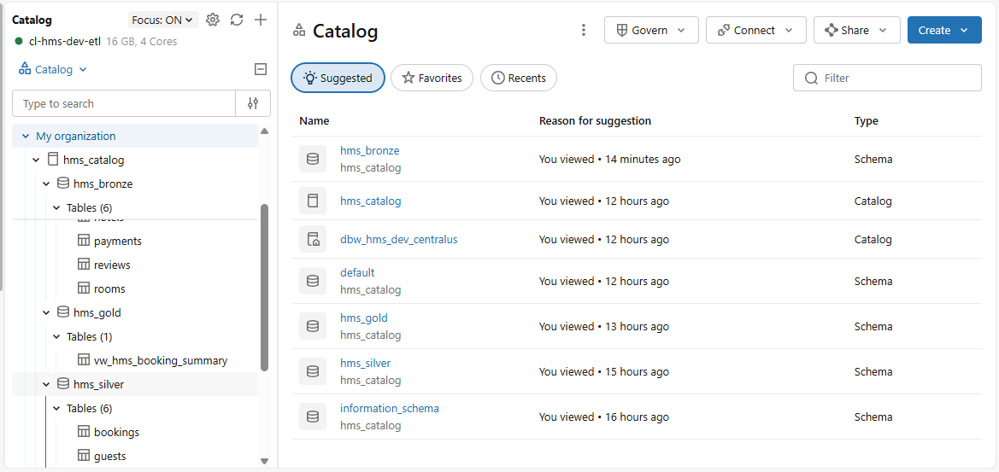«
Step 1.9
«
Notebook3 – pulling data from silver layer and load into delta table in gold layer

dbutils.widgets.text("Catalog_name", "hms_catalog")
dbutils.widgets.text("Schema_name", "hms_silver")

Catalog_name = dbutils.widgets.get("Catalog_name")
Schema_name = dbutils.widgets.get("Schema_name")

check_catalog_availbility ={ rows[0] for rows in spark.sql(f"SHOW CATALOGS LIKE '{Catalog_name}'").collect()
}

if Catalog_name not in check_catalog_availbility:
print(f"Catalog is not verified. Please create the catalog {Catalog_name}")
else:
print(f"Catalog is verified. {Catalog_name}")

check_schema_availbility ={ rows[0] for rows in spark.sql(f"SHOW Schemas IN {Catalog_name}.{Schema_name}").collect()
}

if Catalog_name not in check_catalog_availbility:
print(f"Schema is not verified. Please create the catalog {Schema_name}")
else:
print(f"Schema is verified. {Schema_name}")

Catalog is verified. hms_catalog
Schema is verified. hms_silver

bookings = spark.table("hms_catalog.hms_bronze.bookings")
guests = spark.table("hms_catalog.hms_bronze.guests")
rooms = spark.table("hms_catalog.hms_bronze.rooms")
hotels = spark.table("hms_catalog.hms_bronze.hotels")
payments = spark.table("hms_catalog.hms_bronze.payments")
reviews = spark.table("hms_catalog.hms_bronze.reviews")

df_hms_booking_summary = bookings.join(guests, "guest_id", "inner")\
.join(rooms, "room_id", "inner")\
.join(hotels, "hotel_id", "inner")\
.join(payments, "booking_id", "inner")\
.join(reviews, "hotel_id", "inner")\
.select(

#booking Details
bookings['booking_id'], bookings['check_in'], bookings['check_out'], bookings['booking_status'],bookings['total_amount'],

#guest Details
guests['guest_id'] , guests['guest_city'],guests['guest_age'],

#room Details
rooms['room_id'], rooms['room_type'], rooms['room_price'], rooms['room_status'],

#hotel Details
hotels['hotel_id'], hotels['hotel_name'], hotels['hotel_city'], hotels['hotel_state'], hotels['hotel_rating'], hotels['hotel_phone'],

#payment Details
payments['payment_id'], payments['payment_amount'], payments['payment_method'], payments['payment_status'],

#review Details
reviews['review_id'], reviews['rating'], reviews['review_date'], reviews['review_comments'])

#create view for gold layer
df_hms_booking_summary.write.mode("overwrite").saveAsTable(f"{Catalog_name}.hms_gold.Vw_hms_booking_summary")

«

Step 2.0
Schedule job to run every Monday on 8:00 PM EST
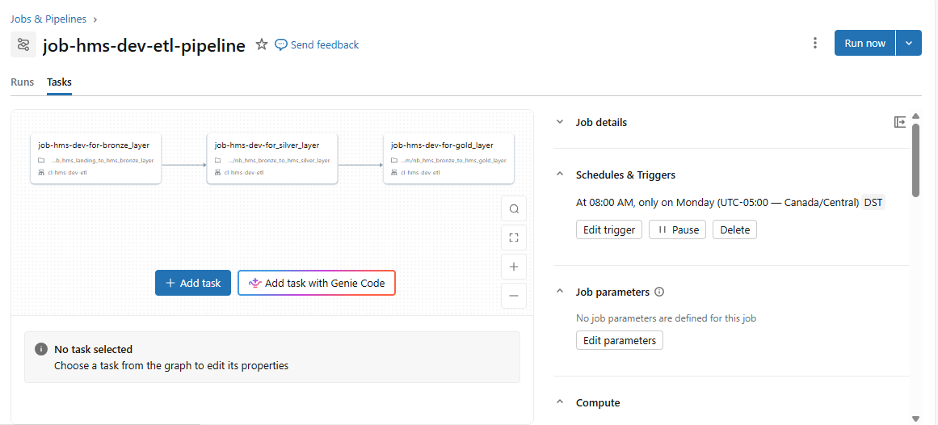

Step 2.1
Manually testing job
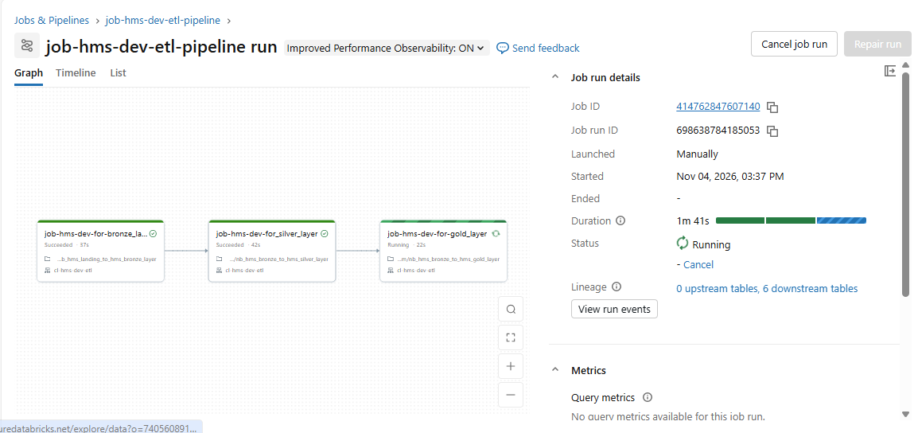

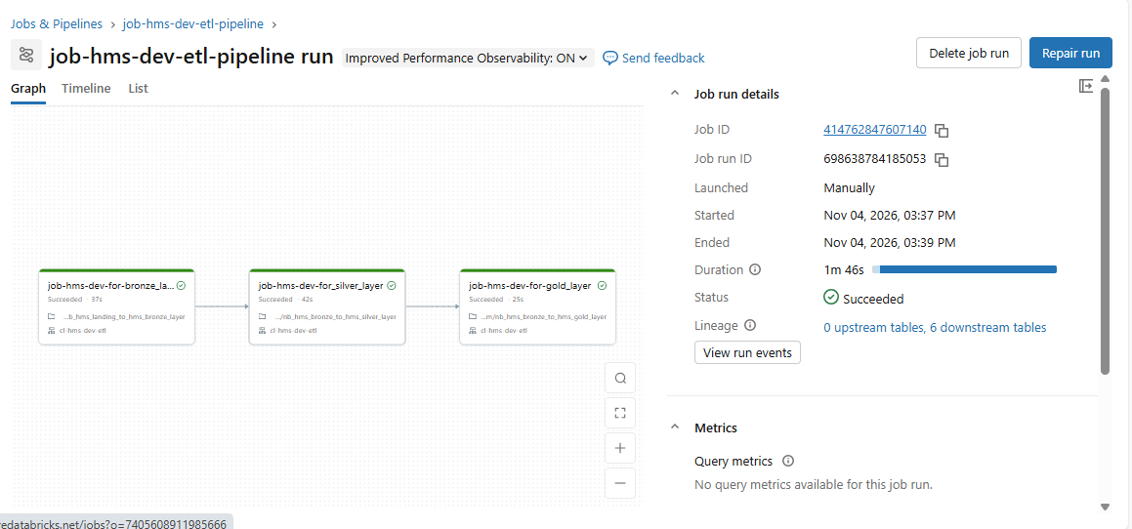

Job successfully run and finally created view for designing dashboard.
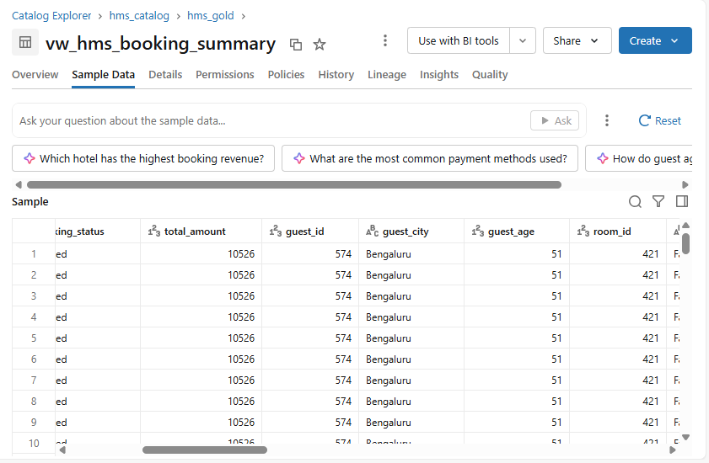

Completed

